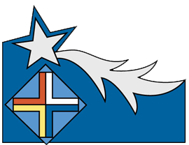

**ASASV Lowell Meeting September 3, 2020**

**Opening prayer:** God of mystery, whose voice whispers our name, gather us now in your one Spirit and prepare our hearts as we journey in faith to listen to one another and bless each other in this our September gathering. We ask this through Christ Our Lord. Amen

**Introduction:** September 8th, 1853 was the beginning of an amazing journey. As we approach the 167th anniversary of the foundation of the Sisters of the Assumption we gather tonight to remember the four brave and vivacious young women who said yes to Fr. Jean Harper. Leocadie Bourgeois, Julie Heon, Mathilde Leduc, and Hedwidge Buisson. They generously accepted to pursue, in community, under the patronage of Our Lady of the Assumption, an apostolic work that would spread throughout the world.

**Reflection**

Kindly read and reflect on the following statements from the four SASV Foundresses.

**Mere St. Joseph**  **(Hedwidge Buisson)**

“Work for the good Lord only, and you will rejoice no matter what events present themselves to you.”

**Mere de L’Assomption (Leocadie Bourgeois)**

**“**Serve well the good Lord, my sisters, for upon death what will remain is what we have done for him.”

**Mere St. Marie (Mathilde Leduc)**

“Silence and meditation are that foundation of the interior life which would necessarily be that of persons consecrated to God.”

**Mere de Jesus (Julie Heon)**

“I have all of eternity to rest.”

**Sharing**

Which of these quotes from the four foundresses speaks to you the most? Why?

How do you see it connect to your commitment as an associate?

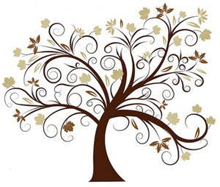

**We Are One Janet Sullivan Whitaker**

We are different from each other you and I

Yet we share this gift of faith in the God who made us

Pray for me, I will pray for you

And we’ll sing together as we walk this path of life.

Refrain We are one, we are one, the body of Christ

Blessed and broken as one family we believe

That if we die to ourselves we will rise up again

Forever united in love, We are one.

(Last) Forever united in love, in the God who made us

Forever united in love, the Body of Christ

Forever united in love, We Are One.

Challenged by the living word of our God

We are called to live as people of the Word made flesh

We believe in what we receive his own body and

Blood given for the life of the world.

Thy Kingdom come, thy will be done

On earth as it is in heaven.