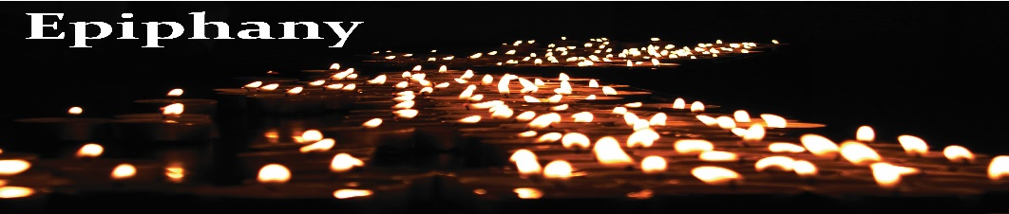**Manifestation of God – Blessings in Darkness and in Light**

**Rise up in splendor! Your LIGHT has come!** (Is 60: 1)

Holy Light, searcher of the human heart, guide and beacon of eternal hope—pour your radiance into our very souls. Brighten the darkness within... Enlighten our minds. Open our hearts. Lift our spirits that we may touch the rays of your divine Love and Light flowing through us and around us. Amen.

*“Sometimes our light goes out, but is blown again into instant flame by an encounter with another human being. Each of us owes the deepest thanks to those who have rekindled this inner light.”* Let us thank God for the blessings of light we have known this past year.

* For families and friends who grew in their appreciation of each other...Thank you, God.
* For those doctors, nurses, aids, EMT personnel, researchers who worked on the front lines of the pandemic with courage, expertise, and total dedication...Thank you, God.
* For all those who, because of their work, helped to keep vital lifelines open: farmers, sanitation workers, truck drivers, aviation personnel, food distributors, postal workers, police forces, military personnel, teachers...and the list goes on. Thank you, God.
* For those who, because of Covid-19, have grown in self-knowledge, patience, self-sacrifice, courage, and thoughtfulness of others... Thank you, God.
* For all leaders and officials who worked with courage and commitment to promote the common good... Thank you, God.
* For the greater awareness and appreciation we have for our connectedness to our global community, and for all the steps taken this past year to care for the health of the beautiful planet we all call home... Thank you, God.
* For the renewed appreciation of our need for human companionship, for in-person conversations, for touch...Thank you, God.
* For those who, despite the very real pain and hardships of 2020, were still able to smile...and for those who made us laugh, thus applying humor’s balm to our painful wounds...Thank you, God.
* For all those who died during this past year—especially those who succumbed to COVID-19...We remind ourselves that our grieving of them underscores our love and affection we have for them...Thank you, God.

Loving Creator, we ask for your blessings on 2021. For we firmly believe that you have been with us in the Past, you are with us in the Present, and you will be with us in the Future. We face the future with wonder and excitement for the refreshing waters and green pastures that might lie ahead for us. At the same time we also face the future with fear and misgivings for the rough roads and dark valleys that we could encounter along the way. So with its experiences of both darkness and light, we entrust 2021 into your loving hands, following the wise words of the writer Corrie Ten Boom who said, *“Never be afraid to trust an unknown future to* *a known God.”* So, Beloved Known One, help us to step into the future, into the year 2021 with deep faith in Providence and with loving hearts ablaze with HOPE.

**For our reflection and sharing:**

***Do any of the words/thoughts/prayers above touch your heart or speak to your experience of being blessed, or of being blessing for others during this time of global pandemic?***

***Can you name someone or something that has stirred the embers of HOPE within you?***



*Lead us to the Light within, that we may be light to one another and make manifest your compassion and love for all people. Amen.*

(See below for lyrics to Song, “The Prayer”)

ASASV – Prayer/Reflection – Jan. 6, 2021

SONG: **The Prayer**

I pray you’ll be our eyes and watch us where we go.

And help us to be wise, in times when we don’t know.

Let this be our prayer, when we lose our way.

Lead us to a place, guide us with your grace, to a place where we’ll be safe.

I’ll pray we’ll find your light and hold it in our hearts.

When stars go out each night, remind us where you are.

Let this be our prayer, when shadows fill our day.

Lead us to a place, guide us with your grace, to a place where we’ll be safe.

A world where pain and sorrow will be ended.

And every heart that’s broken will be mended.

And we’ll remember we are all God’s children

Reaching out to touch you, reaching to the sky.

We ask that life be kind and watch us from above.

We hope each soul will find, another soul to love.

Let this be our prayer, just like every child,

Needs to find a place, guide us with your grace, give us faith so we’ll be safe.